

Ants Surf & Skate Shop,
℅: The Statistics Network,
Unit 10,
271 Antill Street,
Watson, Canberra,
ACT, Australia.

`
This report is compiled by “The Statistics Network” (SN) as a pilot project to understand the scope for future collaboration between small businesses in Australisian and research institutions (through statistical applications). Our vision is to use the statistical reporting tools commonly applied in scientific applications and teaching in universities to inform small businesses.

The pilot report uses real small business data generated by my own personal small business (Ants Surf&Skate Company). I have used this data as an example of how everyday data (information) and big data (generally speaking from the internet) can provide useful insights for even the smallest local start-ups. Within the report, I first provide a demographic understanding of the suburb where “Ants Surf&Skate Company” is located for trading purposes. The data presented in this section is developed using one of the first “Statistics Network” templates.

As I continue to develop “The Statistics Network” these reports will extend to shiny applications (data visualisation that will allow the user to modify the output through a simple web-browser (see example here in the future!).

Thanks for your time,

Anthony Davidson

Business Plan

Business statement (Company Overview)
This local ACT business buys and sells second-hand surfing and skateboarding equipment. We are a small start-up with low overheads. We keep our overheads low by collaborating with exsisting businesses. We further strengthened these links by reducing the time lag between tertiery research outputs and small business.

We will have limited but accessible hours at this location in an aim to sell Secondhand surfboards and gear to both foot traffic and social media platforms (Insta and Facebook). The data presented in this report has also been used as part of the decision making processes during the set-up and day-to-day running of the surf shop.

We make coffee from 7am at Siam Twist (@siamtwist) and the surfboards will be out from Thursday - Saturday till Christmas. Come by and have a coffee and chat surfing/skating.

FB

“”
FB -draft
“We are the only Canberra surf and/or skate shop that buys and sells second-hand gear. We stock a wide range of beginner to intermediate boards as well as “pro” gear at affordable rates.”

Project goals
This project is focused around building a small business in conjunction with the statistical support provided by the statistics network from the 1st November 2018 till the 24th December 2018. By using the statistics network we are able to show how through community structure we are able to provide economic stavility. Additionally, I have contructed the economic structure (see Mana) that will allow this within companies that work along side the statistics network.

Timetable/roster
See the draft timetable in the link to calendar.
See the draft rosters here

Market Analysis

Coming soon….

[For this project we have not had sufficient time to do an full in-depth market analysis however into the future we hope that this will be possible for all projects. Additional to this, by collecting and analysis some of the data available for the Hackett suburb in the reproducible format the Statistics Network uses means that any additional analysis will reduce in time and subsequent cost.]

Competition
One of our key strengths is that there is little competition within the community for surfboards. However, there is significant competition in the regional and international markets for new and secondhand boards. In Australia the profit margin on new boards is often very low ($300 wholesale for $349-399 retail hearsay from one shop).

This competition highlights the fact that we are focused on local advertising and local marketing. To meet the statistics network aims we will use statistics and data to help drive this.

Competition is distance and ……

Ding pple

Surf shop pple

Marketing Strategy

Logo and other such design issues….
Image | Notes | File name/location

Facebook and instagram marketing (luke)
- What is the cost of this?

Advert image | Words | Cost

Fliers around Hackett and other suburbs
- Simple design targeting key demographics
- Or funky surfboard half signs?

University
- FLiers but send people to drop-off location on Wednesday Mornings (9-12)?

- EventBright for sat fixes

- UC Chat - prep mail...or just use poster??

Commercial shops
- Surf shop? How many and where? JUST ONE
  - WaterSports deal is good. 50/50 profit margin
  - Poster here?
  - Ding poster
  - Repair cost sheet (here)

  - Osto Hackett ok with two posters

- Skate shops
  - 10% off at one in civic mall.
  - Still more in civic and belco malls??
  - Don’t waste too much time in malls as all big corporates

Other coffee shops?
- Braddon coffee - maybe a fine cone grind?
- Momo - surfboard sign hideaway

Customised desktop
- Good marketing option (like SAS but for your business)
- Basic wrapper for census data as dynamic business card

Business card
- QR code

Business Structure and Management
???

Location and coffee resources supplied by Andrew
The Hacket Surf Shop supplies surf apparel and gear.
Luke provides marketing
The Bold does web design

that result in state and federal funding allocation for things like the placement of new schools and hospitals, prioritising roading projects and support for small businesses globally. As with all statistical models of data, the results presented here are only representation of the data.
???

Finances
Contact the The Statistics Network for further details regarding project finances.

Action Plan
Below is the “runsheet” for the project with key dates and deadlines.

Time | Hope to do | MUST | Actually happened
Friday 9th November | Collect boards and feedback from Melbourne community…  Will be back on Tuesday/Weds | Anthony
Wednesday 11h November | Surfboard signage  Hackett shop ~  COMING SOON…  22nd November 2018  Bruce shop  Buy, Selling and Repair surfboards…  Facebook: @ants_surfboards  Will have finalised posters and other things by then | Anthony, Luke and Ian?
Thursday 12th November | 8-10 cafe work/observe  Canberra - Uni 12pm-5pm | Anthony
Friday 13th November | 8-10 cafe work/observe  Ding repairs 12-5pm
Saturday 14th November | 8-10 cafe work/observe  Ding repairs 12-5pm
Sunday 15th November | Ding repairs 12-5pm
Monday 16th November
Tuesday
Wednesday
Thursday 22nd November 2018 | OFFICIAL START |  | OFFICIAL START - delayed!!
Friday 23rd November 2018
Saturday 24th November 2018 | Few old skaters maybe...see how it goes
Sunday 25th November 2018 | Pick-up two skateboards | Pick-up
Monday 26th November 2018
Tuesday 27th November 2018
Wednesday 28th November 2018
Thursday 29th November 2018 | OFFICIAL START
Friday 30th November 2018
Satuerday 1st December 2018

Appendix three: SWAT Analysis Template
See file here.

Appendix four: Project network
Project team
Connectors | Contact | Key cont. and tasks
Business partners
Anthony Davidson | The statistics network  44 Dalyell Street,  Chisholm,  ACT, 2609  Australia | Founder
Sonny | Momo Cafe,  14 Thynne street Bruce | Supporting Founder
Andrew | Siam Twist,  Hackett,  Canberra,  ACT,  Australia | Mutual business partner
Luke Urquhart | Marketing and advertising,  Auckland,  NZ | Founder? Partner? Employee?  - depends on what happens
Advisors ++
Graham Carsey | Quarry Beach Surfboards,  South Dunedin,  Otago,  NZ | - Advisor
Sam Burns | Barrio Collective Coffee,  0423100814  Braddon,  ACT,  Australia | - Advisor  - Potential collaboration  - Market insight and advice
Ian Dudley | Onsite marketing and design,  Canberra,  ACT,  Australia | - Advisor/  - potential employee
Stefan Mayer | Statistical Advisor,  Dunedin,  NZ | - Advisor/  - potential employee
John Beattie | Intellectual property rights,  Wanaka,  NZ | FInancial and legal advisor
Jo
Future staff
Carey Brookes | Canberra, ACT, Australia | Potential employee
Angus Beattie | Melbourne | Potential data analyst
Stockists
Will FOrward | SustanaStraw,  Melbourne,  Australia | - Wholesaler
Surfboard distributors | North Narrabeen  beginner shop…  Australia | - SevenS step-up $300 sell for $399
Canberra WaterSports | Fyshwick….  Australia | - Quick stockist (50/50 on profit)  - Plastic fins fcs = $50 sell for $64.95

Appendix five: Drone impact survey

Stocky the Drone (For more details see here.)A multi-disciplinary collaboration between the Institute of Applied Ecology (IAE); the Statistical Support Network (SSN) and ACT civil surveys (ACTsurv) to help save the stocky galaxias

Appendix six: Contact details
Useful Phone Numbers
Name | Number
Anthony Davidson | 0449521143
UC Security | 6201 2222
Hotel Hotel | 6287 6287
Taxi | 13 22 27

Appendix six: BootCamps in Melbourne
Draft of a “working business proposal” can be found here.
Draft of “scope of works” is here.
Resources can be found here.

Appendix seven: App for stockTaking UC wide
Draft of a “working business proposal” can be found here.
Draft of “scope of works” is here.
Resources can be found here.

Appendix eight: University of Canberra SSN network trial
The final report is confidential. Enquire through the University of Canberra here.

Appendix nine: University of Canberra SSN funding proposal
Draft of a “working business proposal” can be found here.
Draft of “scope of works” is here.
Resources can be found here.

Appendix ten: Budget
Find full budget here.

Appendix eleven:.Results
The suburb of Hackett is situated in the state of ACT in Australia. From 2016 census data it is possible to draw a very broad understanding of the demography of the area.
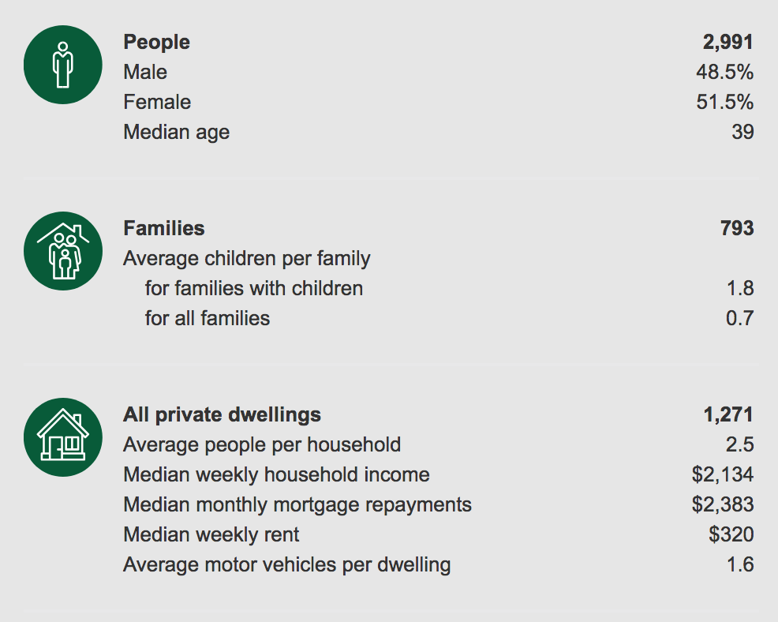

Figure 1: [Webpage screenshot of basic demographic data of the Hackett suburb. See: http://quickstats.censusdata. abs.gov.au/census_ services/getproduct/census /2016/quickstat/SSC80068

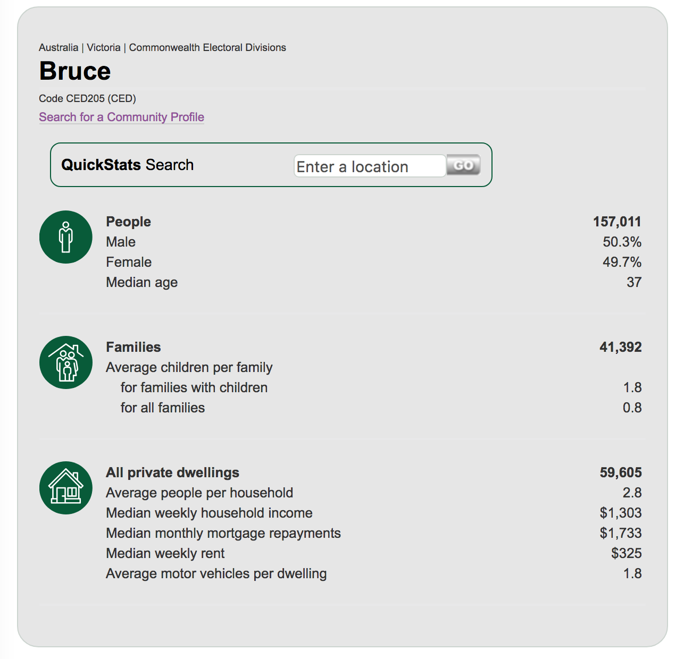

Figure 2: [Webpage screenshot of basic demographic data of the Bruce suburb. See: http://quickstats.censusdata.abs.gov.au/census_services/getproduct/census/2016/quickstat/CED205

If we are to compare Hackett for example with Bruce (Figure 2) we see that there is a considerable difference in the median monthly income. Now this is likely to be to do with the student component of the Bruce suburb (a issue of confounding effects).

For this project I have written a simple survey for customers to do well waiting for there coffee or surfboard stuff. This is a way of making a database of Canberra Surfers and to assess what the needs of the community are. This will be done by simply collecting the data used for research and marketing.

Project team
Connectors | Contact | Key cont. and tasks
Anthony Davidson | The statistics network  44 Dalyell Street,  Chisholm,  ACT, 2609  Australia | Founder
Andrew... | Siam Twist,  Hackett,  Canberra,  ACT,  Australia | Partner
Luke Urquhart | Marketing and advertising,  Auckland,  NZ | Undefined currently

Appendix twelve: Marketing approach

<- Below are a few tools we can and will use in the future. ->

Keyword analysis
Demographic analysis
PCA and other variations of principal component analysis

<- Above are a few tools we can and will use in the future. ->

Keyword analysis
For this I have searched for all the following keywords fixed by location (100km radius of canberra central). These are the results:

No surfboard repair or shaping locations in the area.

Gumtree

Facebook Marketplace

Retail shops
Can this be a always updating evernote table?

Retail Store | Location | Notes
WaterSports Canberra | Fyshwick | 50/50 profits

Individual investor objectives
 | Siam Twist | Hackett Surf Shop | Kristiaan Sinclair - Bootcamp Instructor | The Statistics Network
Objectives | - Have a well trained barista  - Someone to open shop and give Andrew a break in mornings.  - Increase client outside of the current market  - Survey for Andrew (S1) | - Learn coffee  - Create three community events (surf, skate, surf)  - Sell second-hand boards  - Teach how to do ding repairs/hobby workshop on second surf day | - Market Melbourne based Bootcamps on social media  - Hypothesis test customer profiles and locations  - Increase number of weekly bootcamps | - Evidence to show how community structure leads to economic stability
Resources | Location, Location, Location | Start-up opportunities | Facebook, Instagram, Eventbrite?  Small marketing budget, looking for best way to spend it | First official project funded and supported by the Network (evidence building)
Other notes

